# 20200615
# https://fsd.tcsbank.ru/case/4097057/info
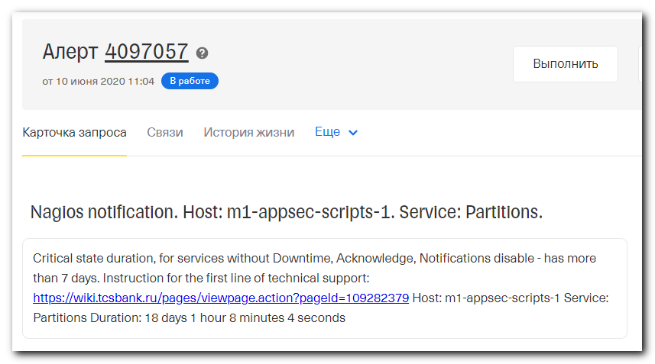
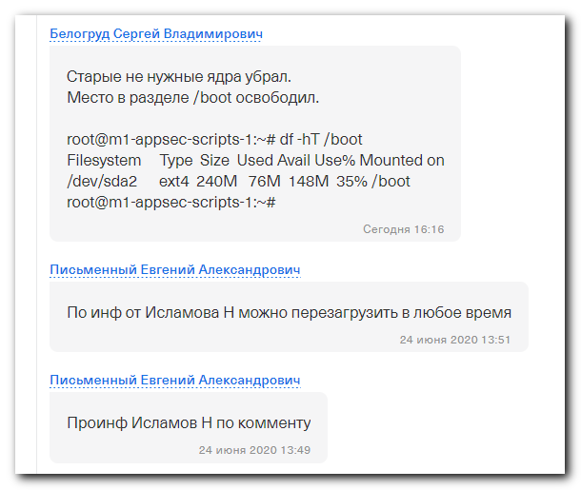
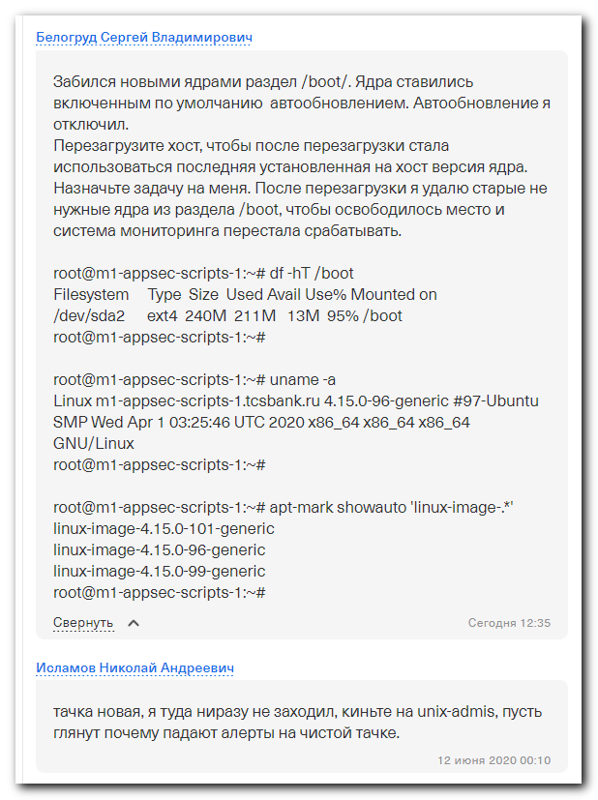

Забился новыми ядрами раздел /boot/. Ядра ставились включенным по умолчанию автообновлением. Автообновление я отключил.
Перезагрузите хост, чтобы после перезагрузки стала использоваться последняя установленная на хост версия ядра. Назначьте задачу на меня. После перезагрузки я удалю старые не нужные ядра из раздела /boot, чтобы освободилось место и система мониторинга перестала срабатывать.

root@m1-appsec-scripts-1:~# df -hT /boot
Filesystem Type Size Used Avail Use% Mounted on
/dev/sda2 ext4 240M 211M 13M 95% /boot
root@m1-appsec-scripts-1:~#

root@m1-appsec-scripts-1:~# uname -a
Linux m1-appsec-scripts-1.tcsbank.ru 4.15.0-96-generic #97-Ubuntu SMP Wed Apr 1 03:25:46 UTC 2020 x86_64 x86_64 x86_64 GNU/Linux
root@m1-appsec-scripts-1:~#

root@m1-appsec-scripts-1:~# apt-mark showauto 'linux-image-.*'
linux-image-4.15.0-101-generic
linux-image-4.15.0-96-generic
linux-image-4.15.0-99-generic
root@m1-appsec-scripts-1:~#

#
# Another one experience how to clean /boot partition on Ubuntu server from old kernel versions.
#
# https://linoxide.com/booting/remove-old-kernel-versions-boot-menu/
# https://www.cyberciti.biz/faq/ubuntu-18-04-remove-all-unused-old-kernels/
#

# The server was rebooted. Current kernel is last from the list of installed kernels.
root@m1-di-kurento01:~# uname -a
Linux m1-di-kurento01.tcsbank.ru 4.15.0-101-generic #102-Ubuntu SMP Mon May 11 10:07:26 UTC 2020 x86_64 x86_64 x86_64 GNU/Linux
root@m1-di-kurento01:~# ls -Alh /boot
total 202M
-rw-r--r-- 1 root root 213K May 11 09:08 config-4.15.0-101-generic
-rw-r--r-- 1 root root 213K Jun 24 2019 config-4.15.0-54-generic
-rw-r--r-- 1 root root 213K Apr 22 18:31 config-4.15.0-99-generic
drwxr-xr-x 5 root root 1.0K May 25 14:40 grub
-rw-r--r-- 1 root root 56M May 24 06:39 initrd.img-4.15.0-101-generic
-rw-r--r-- 1 root root 56M May 21 06:58 initrd.img-4.15.0-54-generic
-rw-r--r-- 1 root root 56M May 21 06:59 initrd.img-4.15.0-99-generic
drwx------ 2 root root 12K Jan 17 2019 lost+found
-rw------- 1 root root 3.9M May 11 09:08 System.map-4.15.0-101-generic
-rw------- 1 root root 3.9M Jun 24 2019 System.map-4.15.0-54-generic
-rw------- 1 root root 3.9M Apr 22 18:31 System.map-4.15.0-99-generic
-rw------- 1 root root 8.0M May 11 09:14 vmlinuz-4.15.0-101-generic
-rw------- 1 root root 8.0M Jun 24 2019 vmlinuz-4.15.0-54-generic
-rw------- 1 root root 8.0M Apr 22 18:32 vmlinuz-4.15.0-99-generic
root@m1-di-kurento01:~#

# Here is a list of kernels, that was automatically installed.
root@m1-di-kurento01:~# apt-mark showauto 'linux-image-.*'
linux-image-4.15.0-101-generic
linux-image-4.15.0-54-generic
linux-image-4.15.0-99-generic
root@m1-di-kurento01:~#

# Here is a list of all kernels.
root@m1-di-kurento01:~# dpkg --list | egrep -i --color 'linux-image|linux-headers'
ii linux-headers-4.15.0-101 4.15.0-101.102 all Header files related to Linux kernel version 4.15.0
ii linux-headers-4.15.0-101-generic 4.15.0-101.102 amd64 Linux kernel headers for version 4.15.0 on 64 bit x86 SMP
ii linux-headers-generic 4.15.0.101.91 amd64 Generic Linux kernel headers
ii linux-image-4.15.0-101-generic 4.15.0-101.102 amd64 Signed kernel image generic
ii linux-image-4.15.0-54-generic 4.15.0-54.58 amd64 Signed kernel image generic
ii linux-image-4.15.0-99-generic 4.15.0-99.100 amd64 Signed kernel image generic
ii linux-image-generic 4.15.0.101.91 amd64 Generic Linux kernel image
rc linux-image-unsigned-4.15.0-48-generic 4.15.0-48.51 amd64 Linux kernel image for version 4.15.0 on 64 bit x86 SMP
root@m1-di-kurento01:~#

# There is no space in /boot partition to purge old kernels.
root@m1-di-kurento01:~# apt-get --purge autoremove
Reading package lists... Done
Building dependency tree
Reading state information... Done
0 upgraded, 0 newly installed, 0 to remove and 0 not upgraded.
1 not fully installed or removed.
After this operation, 0 B of additional disk space will be used.
Setting up initramfs-tools (0.130ubuntu3.9) ...
update-initramfs: deferring update (trigger activated)
Processing triggers for initramfs-tools (0.130ubuntu3.9) ...
update-initramfs: Generating /boot/initrd.img-4.15.0-101-generic

gzip: stdout: No space left on device
E: mkinitramfs failure find 141 cpio 141 gzip 1
update-initramfs: failed for /boot/initrd.img-4.15.0-101-generic with 1.
dpkg: error processing package initramfs-tools (--configure):
installed initramfs-tools package post-installation script subprocess returned error exit status 1
Errors were encountered while processing:
initramfs-tools
E: Sub-process /usr/bin/dpkg returned an error code (1)
root@m1-di-kurento01:~#
# Now I directly remove one old kernel. But for unknown shit - additional package will be installed… WTF?
root@m1-di-kurento01:~# apt remove linux-image-4.15.0-54-generic
Reading package lists... Done
Building dependency tree
Reading state information... Done
The following additional packages will be installed:
linux-image-unsigned-4.15.0-54-generic

# After remove - some idditional space appeared.
root@m1-di-kurento01:~# df -hT /boot
Filesystem Type Size Used Avail Use% Mounted on
/dev/sda2 ext4 240M 181M 43M 81% /boot
root@m1-di-kurento01:~# apt-mark showauto 'linux-image-.*'
linux-image-4.15.0-101-generic
linux-image-4.15.0-99-generic
linux-image-unsigned-4.15.0-54-generic
root@m1-di-kurento01:~#

# Shit with autoremove for unkonwn reason doesn’t work...
root@m1-di-kurento01:~# apt-get --purge autoremove
Reading package lists... Done
Building dependency tree
Reading state information... Done
0 upgraded, 0 newly installed, 0 to remove and 0 not upgraded.
root@m1-di-kurento01:~#

# I’ve removed next old kernel.
root@m1-di-kurento01:~# apt remove linux-image-4.15.0-99-generic

# And then, I’ve removed this fricky package.
root@m1-di-kurento01:~# apt remove linux-image-unsigned-4.15.0-54-generic

# At this moment this command did something useful.
root@m1-di-kurento01:~# apt autoremove
Reading package lists... Done
Building dependency tree
Reading state information... Done
The following packages will be REMOVED:
linux-modules-4.15.0-54-generic
0 upgraded, 0 newly installed, 1 to remove and 0 not upgraded.
After this operation, 64.9 MB disk space will be freed.
Do you want to continue? [Y/n] Y
(Reading database ... 106084 files and directories currently installed.)
Removing linux-modules-4.15.0-54-generic (4.15.0-54.58) ...
root@m1-di-kurento01:~#

# Let’s check.
root@m1-di-kurento01:~# update-grub
Sourcing file `/etc/default/grub'
Sourcing file `/etc/default/grub.d/50-curtin-settings.cfg'
Generating grub configuration file ...
Found linux image: /boot/vmlinuz-4.15.0-101-generic
Found initrd image: /boot/initrd.img-4.15.0-101-generic
Found linux image: /boot/vmlinuz-4.15.0-99-generic
Found initrd image: /boot/initrd.img-4.15.0-99-generic
Found linux image: /boot/vmlinuz-4.15.0-54-generic
Found initrd image: /boot/initrd.img-4.15.0-54-generic
done
root@m1-di-kurento01:~#

# Next step is - remove couple of files from /boot, that still stay and belongs to old kernels.
# Here is a way to find what package provides last unused files.
root@m1-appsec-scripts-1:~# ls -Alh /boot
total 72M
-rw-r--r-- 1 root root 213K May 11 09:08 config-4.15.0-101-generic
-rw-r--r-- 1 root root 213K Jun 4 10:16 config-4.15.0-106-generic
drwxr-xr-x 5 root root 1.0K Jun 26 13:05 grub
-rw-r--r-- 1 root root 56M Jun 20 06:37 initrd.img-4.15.0-106-generic
drwx------ 2 root root 12K Jan 17 2019 lost+found
-rw------- 1 root root 3.9M May 11 09:08 System.map-4.15.0-101-generic
-rw------- 1 root root 3.9M Jun 4 10:16 System.map-4.15.0-106-generic
-rw------- 1 root root 8.0M Jun 4 10:29 vmlinuz-4.15.0-106-generic
root@m1-appsec-scripts-1:~# grep -irle "101" /boot/grub/grub.cfg
root@m1-appsec-scripts-1:~# dpkg -S /boot/config-4.15.0-101-generic
linux-modules-4.15.0-101-generic: /boot/config-4.15.0-101-generic
root@m1-appsec-scripts-1:~# dpkg -S /boot/System.map-4.15.0-101-generic
linux-modules-4.15.0-101-generic: /boot/System.map-4.15.0-101-generic
root@m1-appsec-scripts-1:~#

root@m1-appsec-scripts-1:~# apt remove linux-modules-4.15.0-101-generic
Reading package lists... Done
Building dependency tree
Reading state information... Done
The following packages will be REMOVED:
linux-modules-4.15.0-101-generic
0 upgraded, 0 newly installed, 1 to remove and 59 not upgraded.
After this operation, 65.3 MB disk space will be freed.
Do you want to continue? [Y/n] Y
(Reading database ... 117701 files and directories currently installed.)
Removing linux-modules-4.15.0-101-generic (4.15.0-101.102) ...
root@m1-appsec-scripts-1:~# ls -Alh /boot
total 68M
-rw-r--r-- 1 root root 213K Jun 4 10:16 config-4.15.0-106-generic
drwxr-xr-x 5 root root 1.0K Jun 26 13:05 grub
-rw-r--r-- 1 root root 56M Jun 20 06:37 initrd.img-4.15.0-106-generic
drwx------ 2 root root 12K Jan 17 2019 lost+found
-rw------- 1 root root 3.9M Jun 4 10:16 System.map-4.15.0-106-generic
-rw------- 1 root root 8.0M Jun 4 10:29 vmlinuz-4.15.0-106-generic
root@m1-appsec-scripts-1:~#

# After all - I recommends to reboot the server. To be sure, that everything was made correct.
#

#
# 20191223
#

SD#3536802
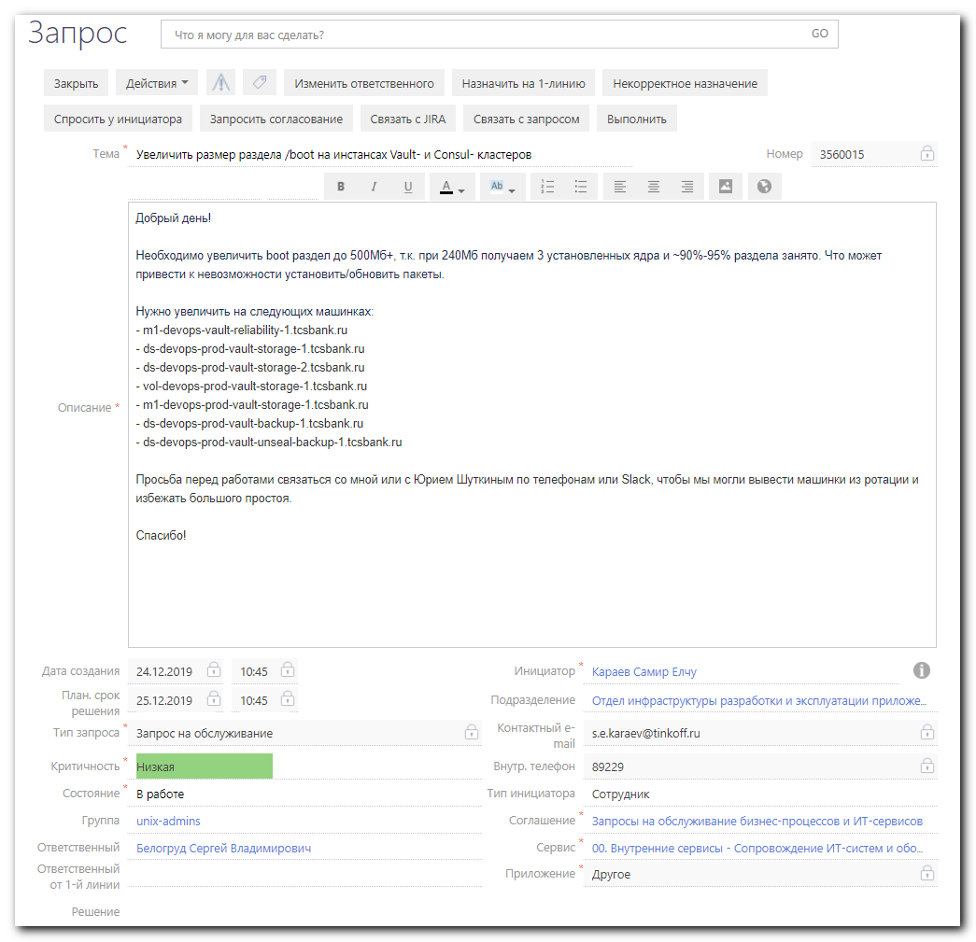

#
# Root of probles is in the /boot partition full. Lot of kernel files there: linux-headers-4.4.0-116 linux-image-4.4.0-116-generic and so on.
# Some requred packages cannot be installed.
# All other packages stuck in that.
#

#
# Follow are steps, which helped me.
#

root@vm-dck-prod-integration03:~# uname -a
Linux vm-dck-prod-integration03.tcsbank.ru 4.4.0-133-generic #159-Ubuntu SMP Fri Aug 10 07:31:43 UTC 2018 x86_64 x86_64 x86_64 GNU/Linux
root@vm-dck-prod-integration03:~#

root@vm-dck-prod-integration03:~# rm /boot/{*-116-*,*-119-*,*-121-*,*-124-*,*-127-*}
root@vm-dck-prod-integration03:~# df -hT /boot
Filesystem Type Size Used Avail Use% Mounted on
/dev/sda1 ext2 472M 228M 220M 51% /boot
root@vm-dck-prod-integration03:~#

root@vm-dck-prod-integration04:~# vim /etc/apt/sources.list

:%s/repo-linux.tcsbank.ru\/ubuntu/repo-linux.tcsbank.ru\/repository\/ubuntu/gc

# TCS REPOS
deb http://repo-linux/repository/ubuntu/ xenial main restricted
deb http://repo-linux/repository/ubuntu/ xenial-updates main restricted
deb http://repo-linux/repository/ubuntu/ xenial universe
deb http://repo-linux/repository/ubuntu/ xenial-updates universe
deb http://repo-linux/repository/ubuntu/ xenial multiverse
deb http://repo-linux/repository/ubuntu/ xenial-updates multiverse
deb http://repo-linux/repository/ubuntu/ xenial-backports main restricted universe multiverse
deb http://repo-linux/repository/ubuntu xenial-security main restricted
deb http://repo-linux/repository/ubuntu xenial-security universe

root@vm-dck-prod-integration03:~# apt-get update

root@vm-dck-prod-integration03:~# apt-get install puppet-agent
Reading package lists... Done
Building dependency tree
Reading state information... Done
You might want to run 'apt-get -f install' to correct these:
The following packages have unmet dependencies:
linux-image-extra-4.4.0-134-generic : Depends: linux-image-4.4.0-134-generic but it is not going to be installed
linux-image-generic : Depends: linux-image-4.4.0-134-generic but it is not going to be installed
Recommends: thermald but it is not going to be installed
puppet-agent : Breaks: facter (< 3.0.0)
Breaks: puppet (< 4.0.0)
Breaks: puppet-common (< 4.0.0)
E: Unmet dependencies. Try 'apt-get -f install' with no packages (or specify a solution).
root@vm-dck-prod-integration03:~# apt-get -f install

root@vm-dck-prod-integration04:~# cat /etc/apt/sources.list.d/tcs-puppet5.list
deb http://repo-linux.tcsbank.ru/puppetlabs/apt/ xenial puppet5
root@vm-dck-prod-integration04:~#
root@vm-dck-prod-integration04:~# apt-get update

root@vm-dck-prod-integration03:~# apt-get install puppet-agent

root@vm-dck-prod-integration03:~# logout
bsv@vm-dck-prod-integration03:~$ sudo -i
root@vm-dck-prod-integration03:~# vim /etc/puppetlabs/puppet/puppet.conf
root@vm-dck-prod-integration03:~# tail -n 2 /etc/puppetlabs/puppet/puppet.conf
# - https://puppet.com/docs/puppet/latest/configuration.html
server = vm-puppetmaster02p.tcsbank.ru
root@vm-dck-prod-integration03:~#

root@vm-dck-prod-integration03:~# puppet agent -t

[root@vm-puppetmaster02p ~]# puppet cert sign vm-dck-prod-integration03.tcsbank.ru
Signing Certificate Request for:
"vm-dck-prod-integration03.tcsbank.ru" (SHA256) A8:FF:67:C1:C6:B0:DC:CC:D1:19:C4:0E:E5:35:FC:CF:76:30:8F:5D:43:76:44:85:E7:B9:BE:33:35:67:3E:42
Notice: Signed certificate request for vm-dck-prod-integration03.tcsbank.ru
Notice: Removing file Puppet::SSL::CertificateRequest vm-dck-prod-integration03.tcsbank.ru at '/etc/puppetlabs/puppet/ssl/ca/requests/vm-dck-prod-integration03.tcsbank.ru.pem'
[root@vm-puppetmaster02p ~]#

root@vm-dck-prod-integration03:~# puppet agent -t

root@ds-devops-prod-vault-storage-2:~# vim /etc/fstab
root@ds-devops-prod-vault-storage-2:~# mkdir /boot_old
root@ds-devops-prod-vault-storage-2:~# mount /boot_old
root@ds-devops-prod-vault-storage-2:~# ls -Alh /boot_old
total 135M
-rw-r--r-- 1 root root 213K Jun 24 2019 config-4.15.0-54-generic
-rw-r--r-- 1 root root 213K Nov 26 11:18 config-4.15.0-72-generic
drwxr-xr-x 5 root root 1.0K Dec 16 04:34 grub
-rw-r--r-- 1 root root 56M Dec 16 04:33 initrd.img-4.15.0-54-generic
-rw-r--r-- 1 root root 56M Dec 16 04:34 initrd.img-4.15.0-72-generic
drwx------ 2 root root 12K Jan 17 2019 lost+found
-rw------- 1 root root 3.9M Jun 24 2019 System.map-4.15.0-54-generic
-rw------- 1 root root 3.9M Nov 26 11:18 System.map-4.15.0-72-generic
-rw------- 1 root root 8.0M Jun 24 2019 vmlinuz-4.15.0-54-generic
-rw------- 1 root root 8.0M Nov 26 11:28 vmlinuz-4.15.0-72-generic
root@ds-devops-prod-vault-storage-2:~# mkdir /boot_old/to_check_new_boot
root@ds-devops-prod-vault-storage-2:~# mv /boot_old/config* /boot_old/to_check_new_boot/
root@ds-devops-prod-vault-storage-2:~# mv /boot_old/initrd* /boot_old/to_check_new_boot/
root@ds-devops-prod-vault-storage-2:~# mv /boot_old/System* /boot_old/to_check_new_boot/
root@ds-devops-prod-vault-storage-2:~# mv /boot_old/vmlinuz* /boot_old/to_check_new_boot/
root@ds-devops-prod-vault-storage-2:~# mv /boot_old/grub /boot_old/to_check_new_boot/
root@ds-devops-prod-vault-storage-2:~# ls -Alh /boot_old/to_check_new_boot/
total 135M
-rw-r--r-- 1 root root 213K Jun 24 2019 config-4.15.0-54-generic
-rw-r--r-- 1 root root 213K Nov 26 11:18 config-4.15.0-72-generic
drwxr-xr-x 5 root root 1.0K Dec 16 04:34 grub
-rw-r--r-- 1 root root 56M Dec 16 04:33 initrd.img-4.15.0-54-generic
-rw-r--r-- 1 root root 56M Dec 16 04:34 initrd.img-4.15.0-72-generic
-rw------- 1 root root 3.9M Jun 24 2019 System.map-4.15.0-54-generic
-rw------- 1 root root 3.9M Nov 26 11:18 System.map-4.15.0-72-generic
-rw------- 1 root root 8.0M Jun 24 2019 vmlinuz-4.15.0-54-generic
-rw------- 1 root root 8.0M Nov 26 11:28 vmlinuz-4.15.0-72-generic
root@ds-devops-prod-vault-storage-2:~# ls -Alh /boot_old/
total 13K
drwx------ 2 root root 12K Jan 17 2019 lost+found
drwxr-xr-x 3 root root 1.0K Dec 27 17:12 to_check_new_boot
root@ds-devops-prod-vault-storage-2:~#

root@ds-devops-prod-vault-storage-2:~# umount /boot_old
root@ds-devops-prod-vault-storage-2:~# vim /etc/fstab
root@ds-devops-prod-vault-storage-2:~# rmdir /boot_old/
root@ds-devops-prod-vault-storage-2:~# ls -Alh /
total 2.1G
drwxr-xr-x 2 root root 4.0K Dec 16 04:32 bin
drwxr-xr-x 4 root root 4.0K Dec 27 16:58 boot
drwx------ 3 root root 4.0K Jan 28 2019 .config
drwxr-xr-x 18 root root 3.9K Dec 27 17:05 dev
drwxr-xr-x 112 root root 4.0K Dec 27 17:14 etc
drwxr-xr-x 19 root root 4.0K Dec 24 15:34 home
lrwxrwxrwx 1 root root 33 Dec 14 06:27 initrd.img -> boot/initrd.img-4.15.0-72-generic
lrwxrwxrwx 1 root root 33 Dec 14 06:27 initrd.img.old -> boot/initrd.img-4.15.0-54-generic
drwxr-xr-x 22 root root 4.0K Jul 25 2018 lib
drwxr-xr-x 2 root root 4.0K Jul 25 2018 lib64
drwx------ 2 root root 16K Jan 17 2019 lost+found
drwxr-xr-x 2 root root 4.0K Jul 25 2018 media
drwxr-xr-x 2 root root 4.0K Jul 25 2018 mnt
drwxr-xr-x 4 root root 4.0K Dec 14 06:05 opt
dr-xr-xr-x 202 root root 0 Dec 27 17:05 proc
drwx------ 6 root root 4.0K Dec 27 17:14 root
drwxr-xr-x 32 root root 1.2K Dec 27 17:08 run
drwxr-xr-x 2 root root 12K Dec 16 04:33 sbin
drwxr-xr-x 4 root root 4.0K Jan 17 2019 snap
drwxr-xr-x 2 root root 4.0K Jul 25 2018 srv
-rw------- 1 root root 2.0G Jan 17 2019 swap.img
dr-xr-xr-x 13 root root 0 Dec 27 17:05 sys
drwxrwxrwt 12 root root 4.0K Dec 27 17:14 tmp
drwxr-xr-x 10 root root 4.0K Jul 25 2018 usr
drwxr-xr-x 13 root root 4.0K Jul 25 2018 var
lrwxrwxrwx 1 root root 30 Dec 14 06:27 vmlinuz -> boot/vmlinuz-4.15.0-72-generic
lrwxrwxrwx 1 root root 30 Dec 14 06:27 vmlinuz.old -> boot/vmlinuz-4.15.0-54-generic
root@ds-devops-prod-vault-storage-2:~#

# 20191227
# Here is a way, how to repair corrupted boot.
#
# https://webhamster.ru/mytetrashare/index/mtb0/132241511571gh6ypk2p
# http://ipmnet.ru/~sadilina/Fedora/335.html
#
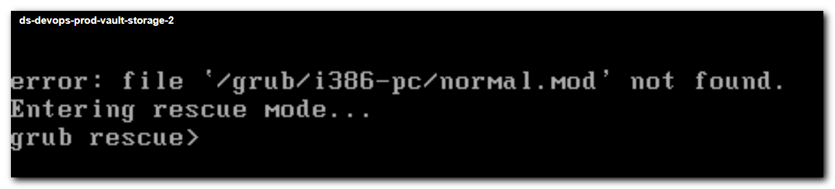
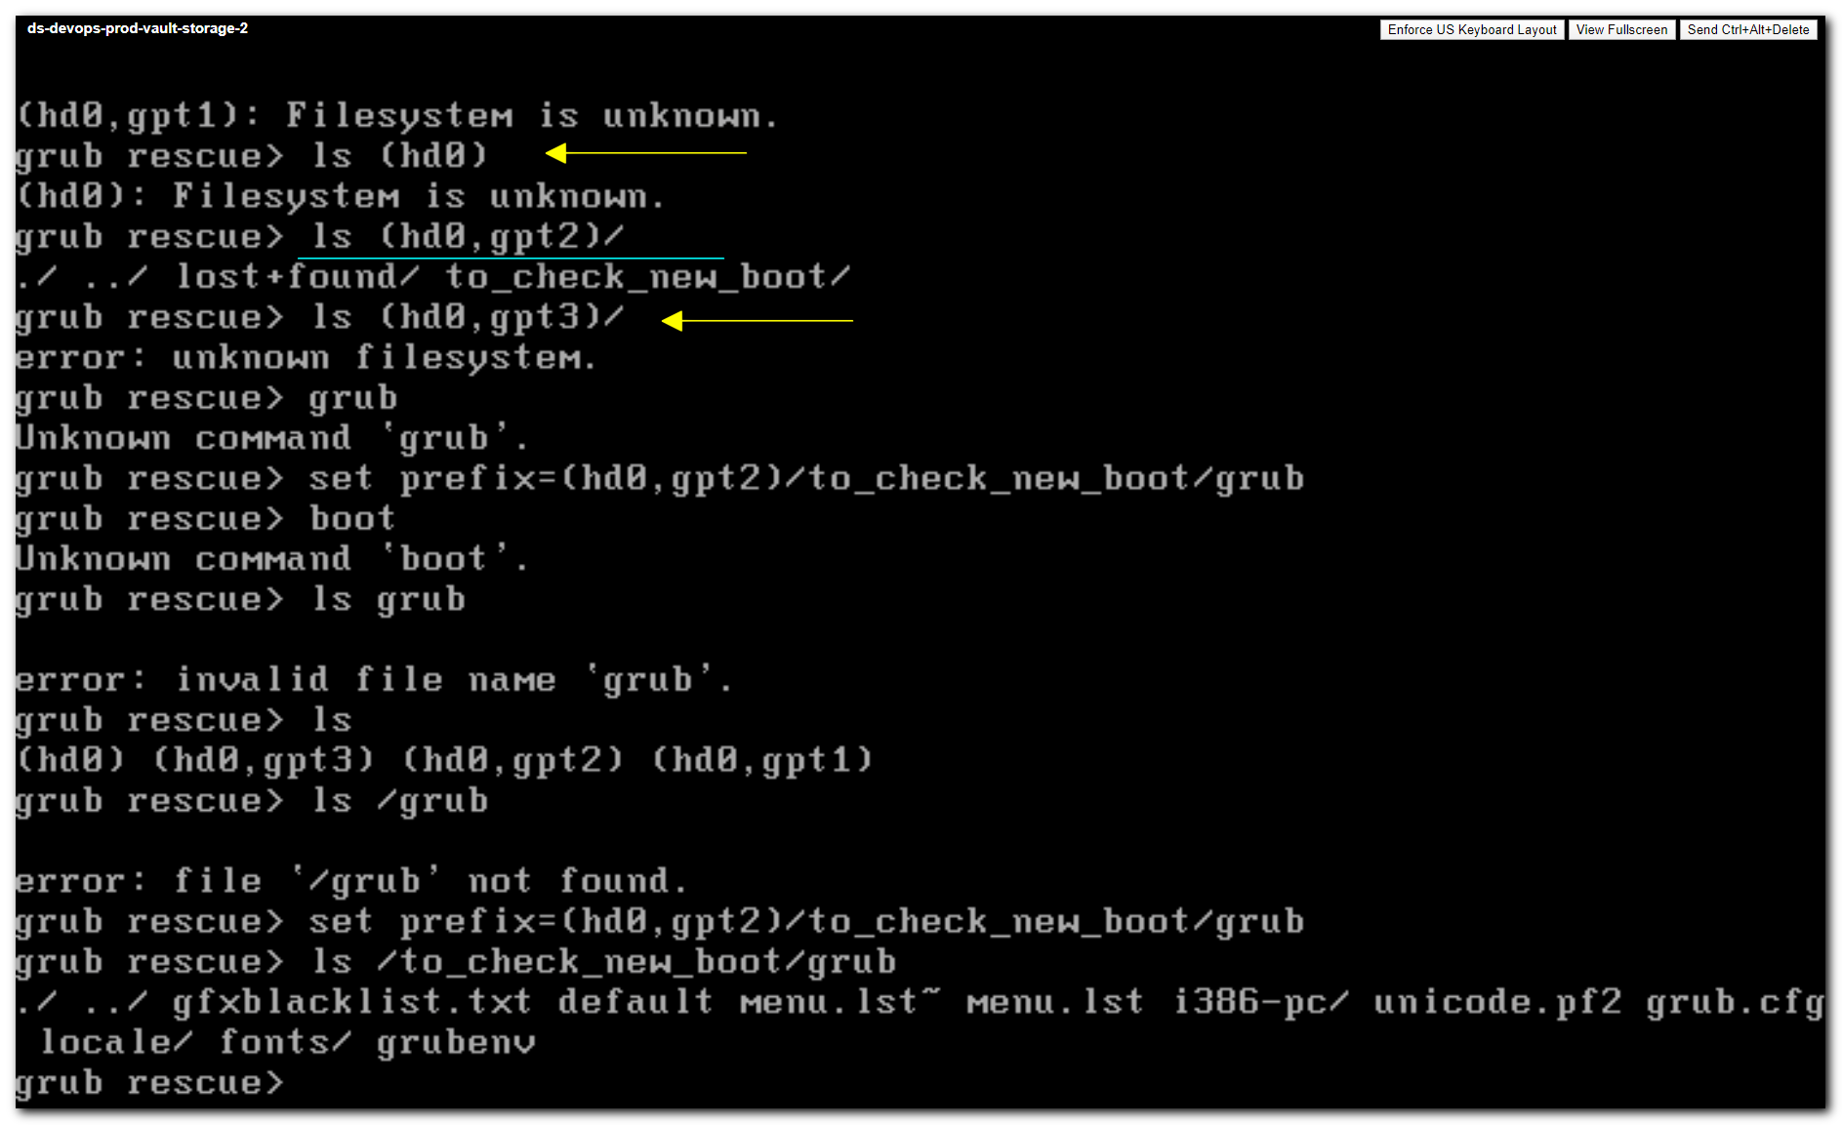
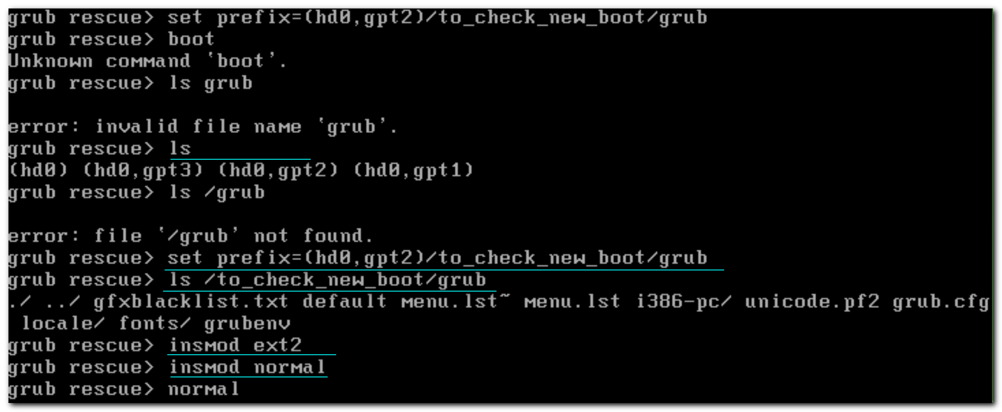
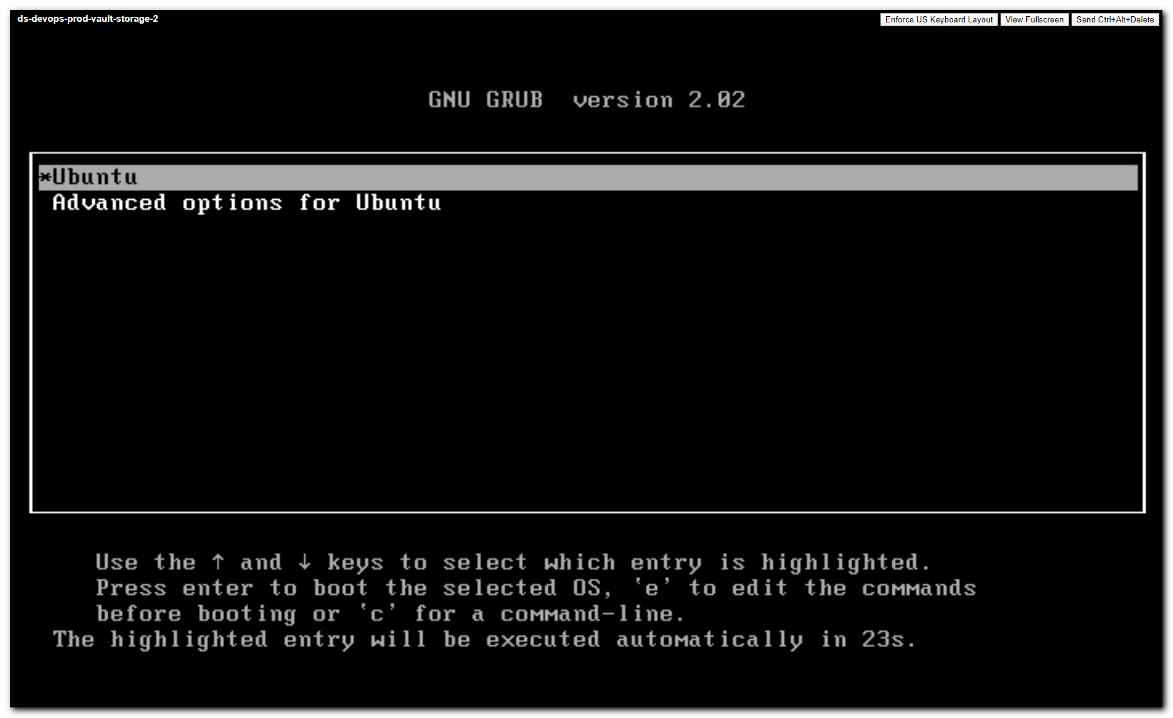
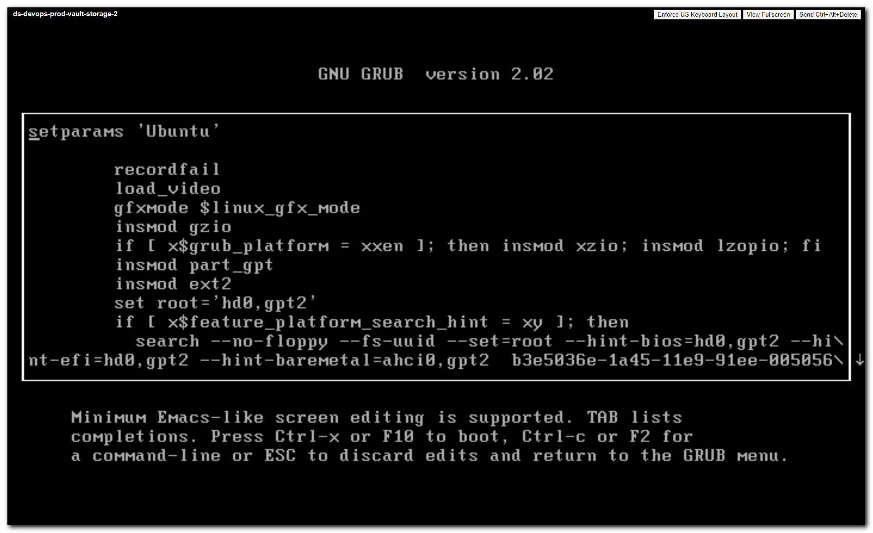
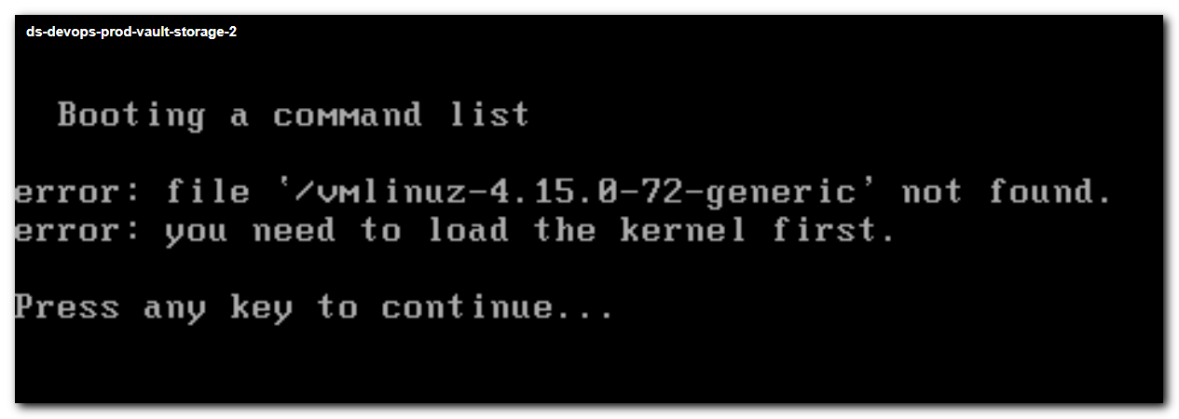
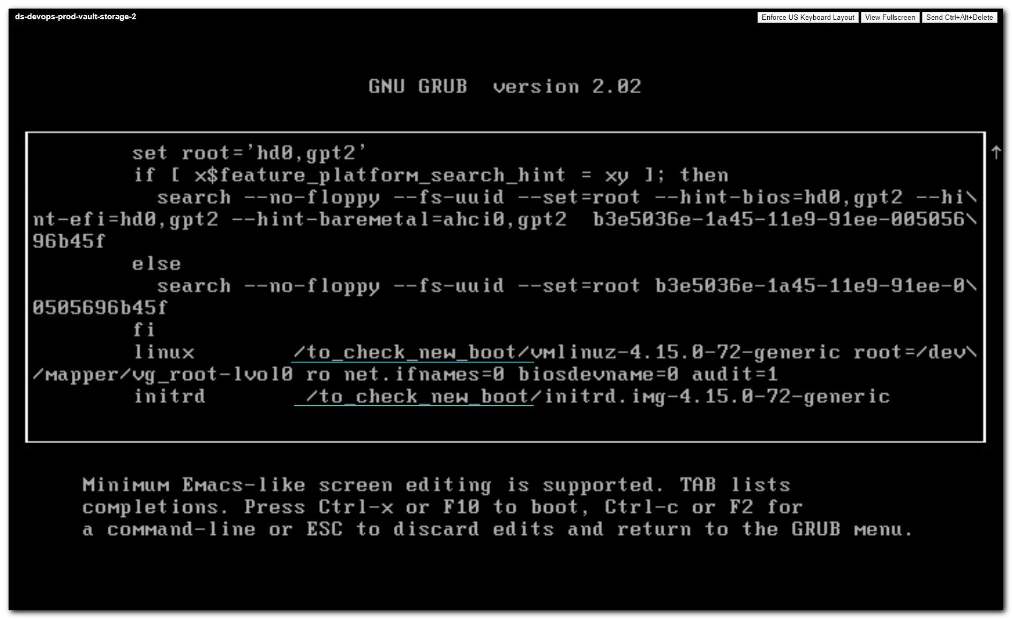
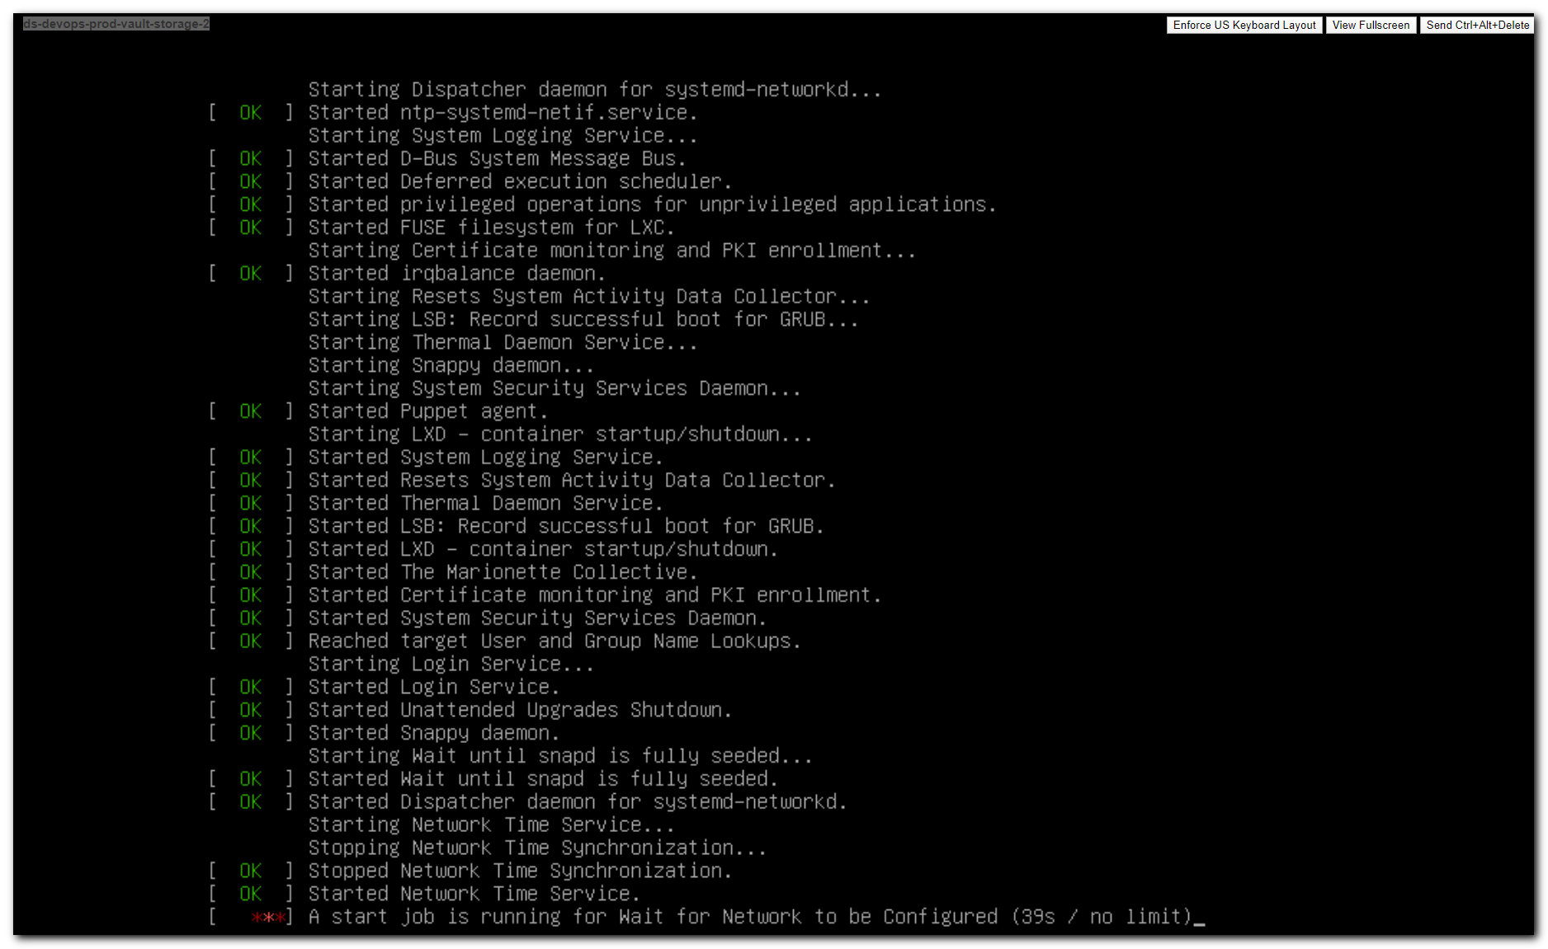

#
# Here is for example how could work boot from partition under lvm and /boot is placed on root partition.
# Ubuntu 18.04.3 LTS
#

root@ds-tcrm-es03:~# lsblk -o NAME,TYPE,MOUNTPOINT,FSTYPE,SIZE
NAME TYPE MOUNTPOINT FSTYPE SIZE
sda disk /data01 ext4 894.3G
sdb disk /data02 ext4 894.3G
sdc disk /data03 ext4 894.3G
sdd disk /data04 ext4 894.3G
sde disk /data05 ext4 894.3G
sdf disk /data06 ext4 894.3G
sdg disk 279.4G
├─sdg1 part /boot/efi vfat 512M
└─sdg2 part LVM2_member 278.9G
├─ds--tcrm--es03--vg-root lvm / ext4 277.9G
└─ds--tcrm--es03--vg-swap_1 lvm swap 976M
root@ds-tcrm-es03:~#

root@ds-tcrm-es03:~# vim -R /boot/grub/grub.cfg
...
menuentry 'Ubuntu' --class ubuntu --class gnu-linux --class gnu --class os $menuentry_id_option 'gnulinux-simple-caa2e01e-ed20-42b6-9ba2-9418196b9f9b' {
recordfail
load_video
gfxmode $linux_gfx_mode
insmod gzio
if [ x$grub_platform = xxen ]; then insmod xzio; insmod lzopio; fi
insmod part_gpt
insmod lvm
insmod ext2
set root='lvmid/QnbyeR-6vOA-66n7-TIfK-k1fl-EeVr-gY601X/d2SbKQ-PE3m-BYvy-TdzQ-zx2c-Pafp-YwJBtz'
if [ x$feature_platform_search_hint = xy ]; then
search --no-floppy --fs-uuid --set=root --hint='lvmid/QnbyeR-6vOA-66n7-TIfK-k1fl-EeVr-gY601X/d2SbKQ-PE3m-BYvy-TdzQ-zx2c-Pafp-YwJBtz' caa2e01e-ed20-42b6-9ba2-9418196b9f9b
else
search --no-floppy --fs-uuid --set=root caa2e01e-ed20-42b6-9ba2-9418196b9f9b
fi
linux /boot/vmlinuz-4.15.0-72-generic root=/dev/mapper/ds--tcrm--es03--vg-root ro
initrd /boot/initrd.img-4.15.0-72-generic
}
...

#
# One partition have to be not under LVM.
#
# https://unix.stackexchange.com/questions/502614/install-grub2-on-lvm-partition
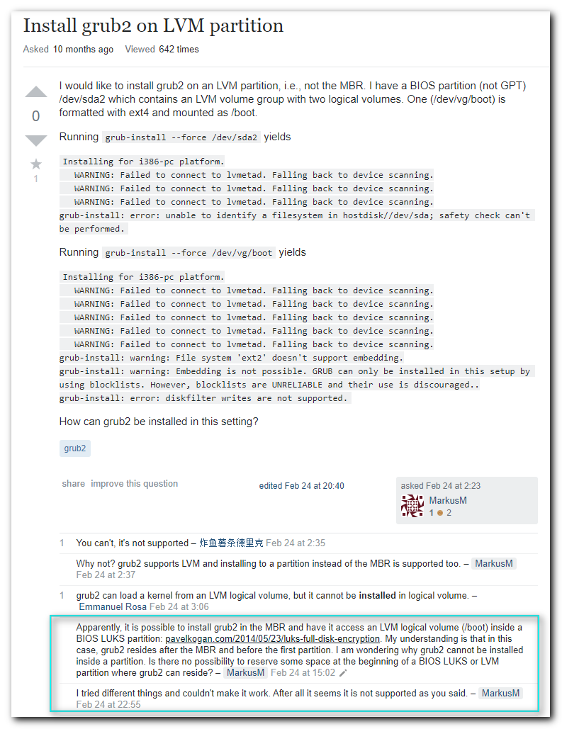

#
# It looks like this partition is not under LVM.
#
root@ds-tcrm-es03:~# ls -Alh /boot/efi
total 4.0K
drwx------ 4 root root 4.0K Nov 25 15:54 EFI
root@ds-tcrm-es03:~# ls -Alh /boot/efi/EFI/
total 8.0K
drwx------ 2 root root 4.0K Nov 25 15:54 BOOT
drwx------ 2 root root 4.0K Nov 25 15:54 ubuntu
root@ds-tcrm-es03:~# ls -Alh /boot/efi/EFI/BOOT/
total 2.5M
-rwx------ 1 root root 1.3M Dec 2 16:11 BOOTX64.EFI
-rwx------ 1 root root 1.2M Dec 2 16:11 fbx64.efi
root@ds-tcrm-es03:~# ls -Alh /boot/efi/EFI/ubuntu/
total 3.6M
-rwx------ 1 root root 108 Dec 2 16:11 BOOTX64.CSV
-rwx------ 1 root root 201 Dec 2 16:11 grub.cfg
-rwx------ 1 root root 1.1M Dec 2 16:11 grubx64.efi
-rwx------ 1 root root 1.3M Dec 2 16:11 mmx64.efi
-rwx------ 1 root root 1.3M Dec 2 16:11 shimx64.efi
root@ds-tcrm-es03:~#

root@ds-tcrm-es03:~# cat /boot/efi/EFI/ubuntu/grub.cfg
search.fs_uuid caa2e01e-ed20-42b6-9ba2-9418196b9f9b root lvmid/QnbyeR-6vOA-66n7-TIfK-k1fl-EeVr-gY601X/d2SbKQ-PE3m-BYvy-TdzQ-zx2c-Pafp-YwJBtz
set prefix=($root)'/boot/grub'
configfile $prefix/grub.cfg
root@ds-tcrm-es03:~#

root@ds-tcrm-es03:~# blkid --uuid caa2e01e-ed20-42b6-9ba2-9418196b9f9b
/dev/mapper/ds--tcrm--es03--vg-root
root@ds-tcrm-es03:~#

root@ds-tcrm-es03:~# vgdisplay
...
VG Name ds-tcrm-es03-vg
...
VG UUID QnbyeR-6vOA-66n7-TIfK-k1fl-EeVr-gY601X
...

root@ds-tcrm-es03:~# lvdisplay
...
LV Path /dev/ds-tcrm-es03-vg/root
LV Name root
VG Name ds-tcrm-es03-vg
LV UUID d2SbKQ-PE3m-BYvy-TdzQ-zx2c-Pafp-YwJBtz
...

#
# This is original grub.cfg.
#
root@ds-devops-prod-vault-storage-2:~# vim -R /boot_old/to_check_new_boot/grub/grub.cfg
...
menuentry 'Ubuntu' --unrestricted --class ubuntu --class gnu-linux --class gnu --class os $menuentry_id_option 'gnulinux-simple-b3e5036f-1a45-11e9-91ee-00505696b45f' {
recordfail
load_video
gfxmode $linux_gfx_mode
insmod gzio
if [ x$grub_platform = xxen ]; then insmod xzio; insmod lzopio; fi
insmod part_gpt
insmod ext2
set root='hd0,gpt2'
if [ x$feature_platform_search_hint = xy ]; then
search --no-floppy --fs-uuid --set=root --hint-bios=hd0,gpt2 --hint-efi=hd0,gpt2 --hint-baremetal=ahci0,gpt2 b3e5036e-1a45-11e9-91ee-00505696b45f
else
search --no-floppy --fs-uuid --set=root b3e5036e-1a45-11e9-91ee-00505696b45f
fi
linux /vmlinuz-4.15.0-72-generic root=/dev/mapper/vg_root-lvol0 ro net.ifnames=0 biosdevname=0 audit=1
initrd /initrd.img-4.15.0-72-generic
}
...

#
# This was made after update-grub command.
# And it looks good, as I see. It similar as I see in ds-tcrm-es03.
#
root@ds-devops-prod-vault-storage-2:~# update-grub
Sourcing file `/etc/default/grub'
Sourcing file `/etc/default/grub.d/50-curtin-settings.cfg'
Generating grub configuration file ...
Found linux image: /boot/vmlinuz-4.15.0-72-generic
Found initrd image: /boot/initrd.img-4.15.0-72-generic
Found linux image: /boot/vmlinuz-4.15.0-54-generic
Found initrd image: /boot/initrd.img-4.15.0-54-generic
done
root@ds-devops-prod-vault-storage-2:~#

root@ds-devops-prod-vault-storage-2:~# vim /boot/grub/grub.cfg
...
menuentry 'Ubuntu' --unrestricted --class ubuntu --class gnu-linux --class gnu --class os $menuentry_id_option 'gnulinux-simple-b3e5036f-1a45-11e9-91ee-00505696b45f' {
recordfail
load_video
gfxmode $linux_gfx_mode
insmod gzio
if [ x$grub_platform = xxen ]; then insmod xzio; insmod lzopio; fi
insmod part_gpt
insmod lvm
insmod ext2
set root='lvmid/XvYXGf-5t4Y-YTbO-KdGw-hhj1-zSq2-ZS9Ifk/Iza6JW-0SGL-qenI-SVnw-e91a-BGxT-RX2LFg'
if [ x$feature_platform_search_hint = xy ]; then
search --no-floppy --fs-uuid --set=root --hint='lvmid/XvYXGf-5t4Y-YTbO-KdGw-hhj1-zSq2-ZS9Ifk/Iza6JW-0SGL-qenI-SVnw-e91a-BGxT-RX2LFg' b3e5036f-1a45-11e9-91ee-00505696b45f
else
search --no-floppy --fs-uuid --set=root b3e5036f-1a45-11e9-91ee-00505696b45f
fi
linux /boot/vmlinuz-4.15.0-72-generic root=/dev/mapper/vg_root-lvol0 ro net.ifnames=0 biosdevname=0 audit=1
initrd /boot/initrd.img-4.15.0-72-generic
}

# https://gparted.org/display-doc.php?name=help-manual#gparted-resize-partition

# SYSTEM RESCUE CD HOMEPAGE
# http://www.system-rescue-cd.org/

GParted Live CD
https://gparted.org/livecd.php

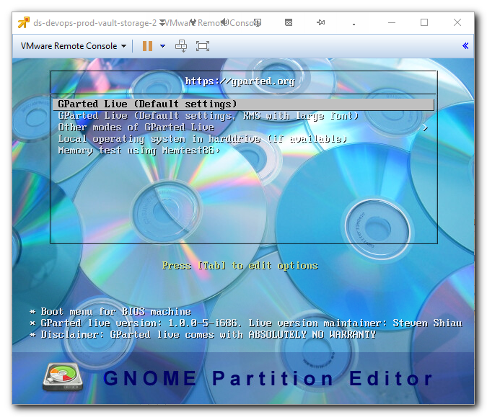
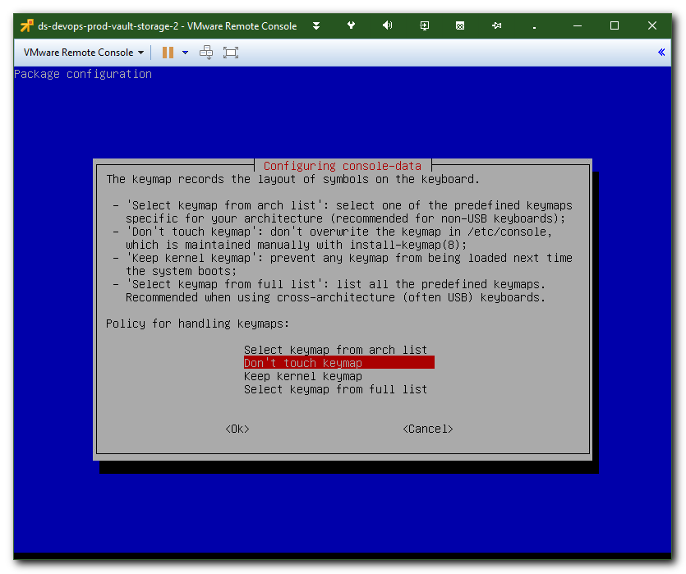
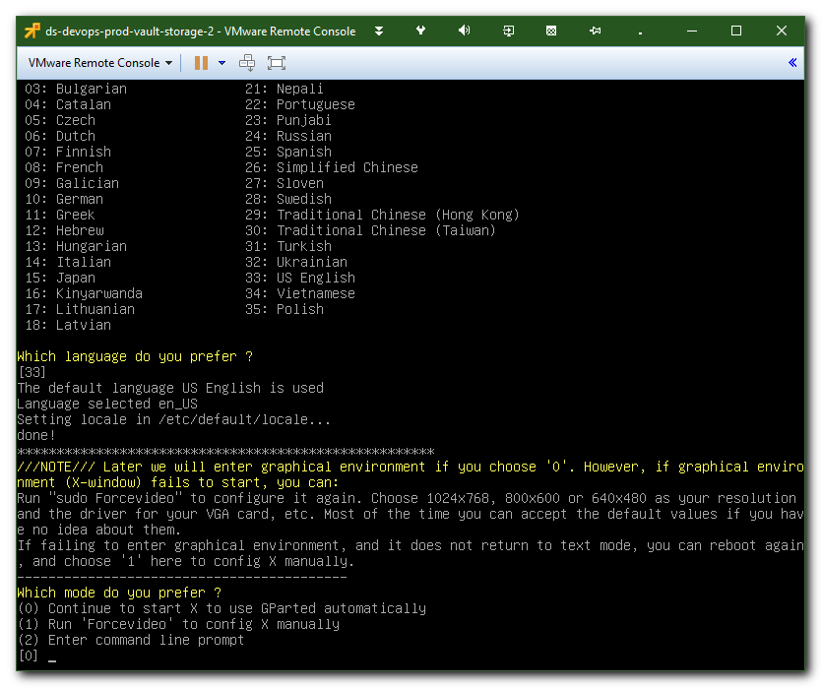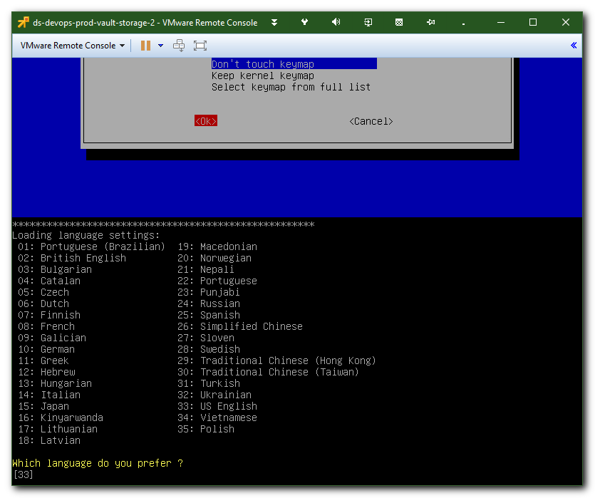
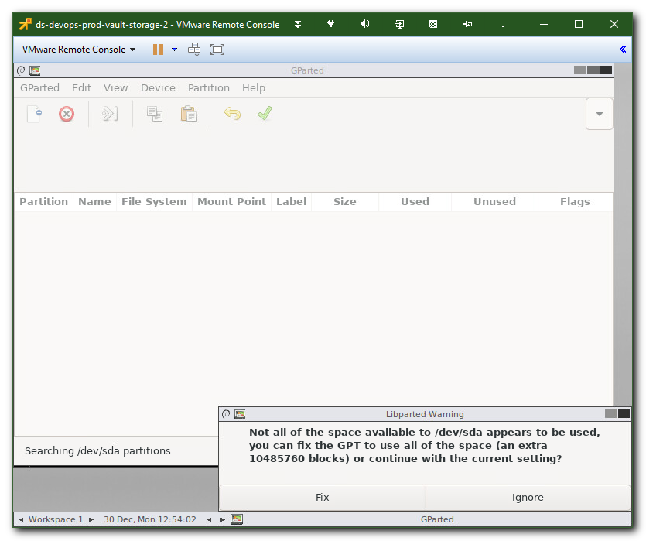
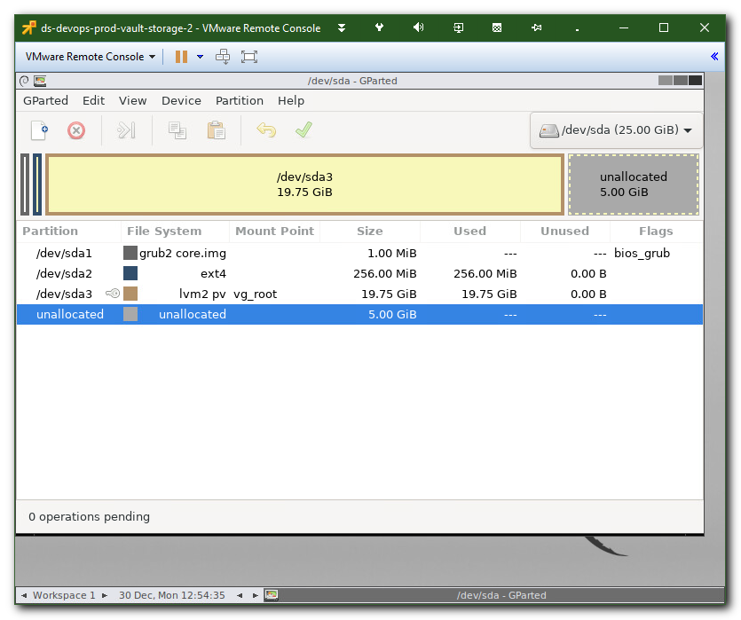
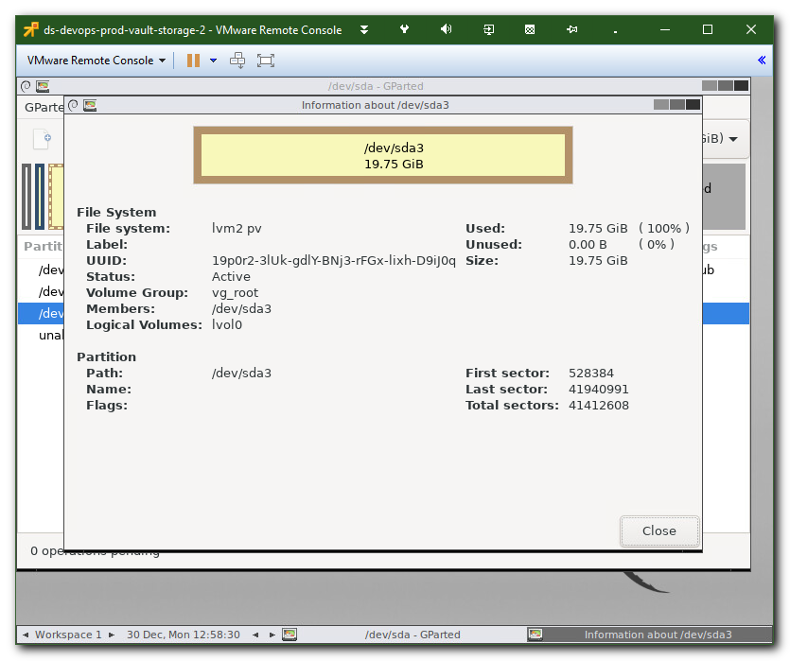
#
# To become move option available - I’ve Deactivated this partition.
# The key sign was disappeared.
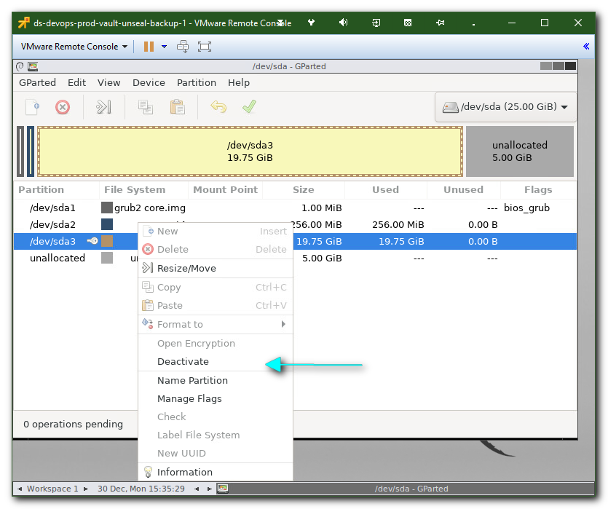
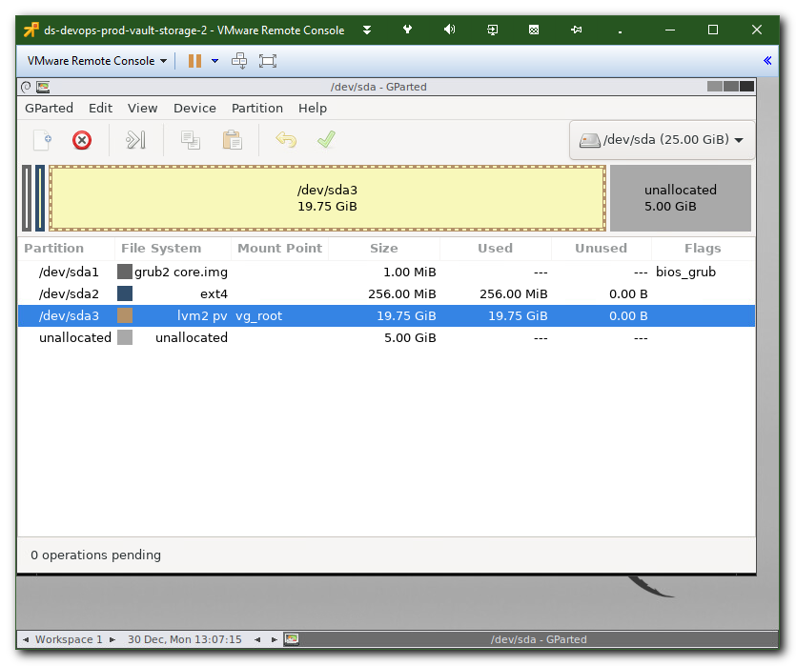
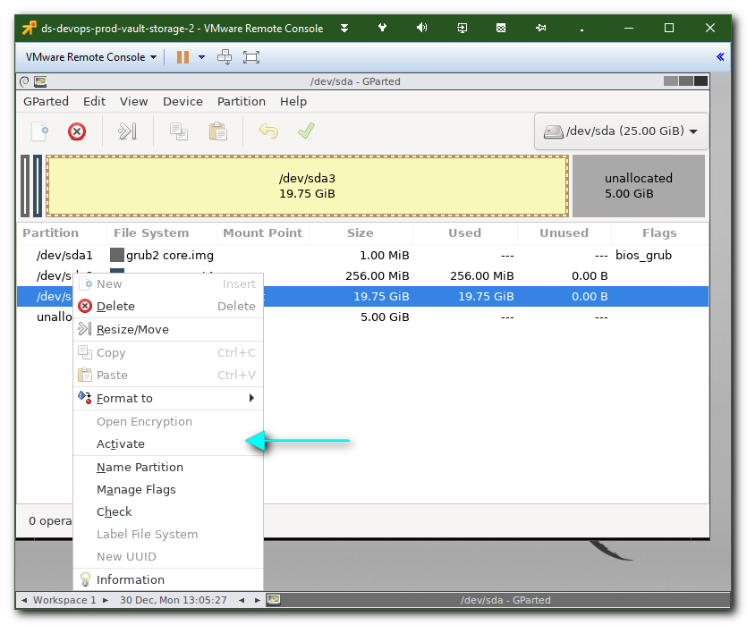
#
# Here I’ve choosen “Resize/Move” and Move option now available.
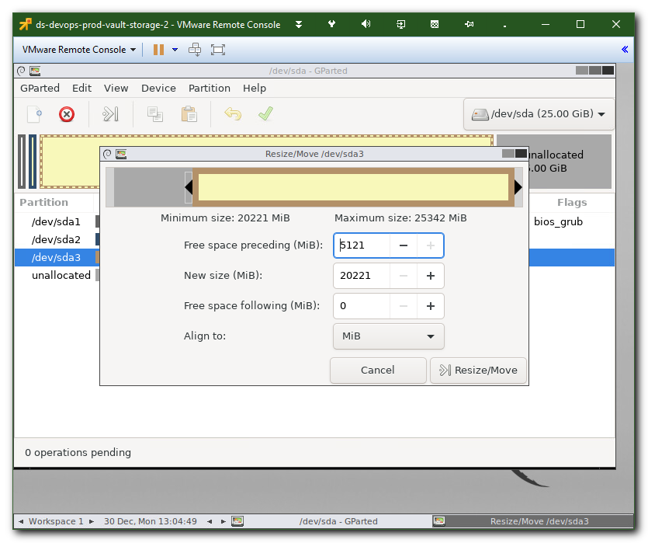
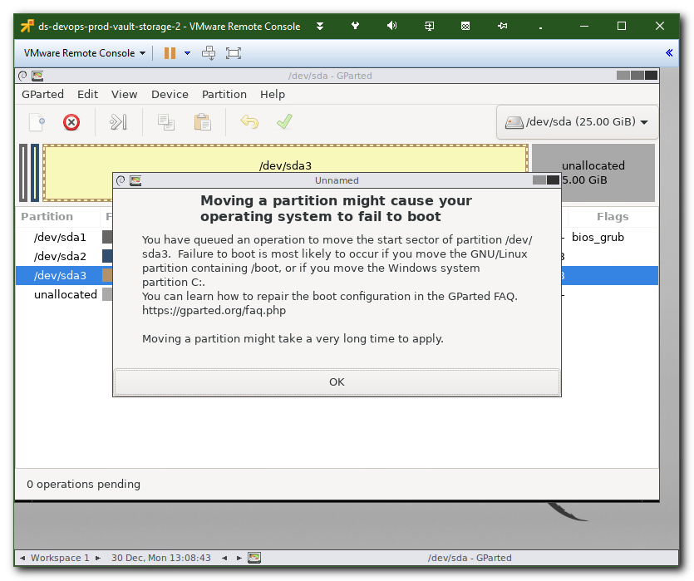
#
# Now I can resize boot partition.
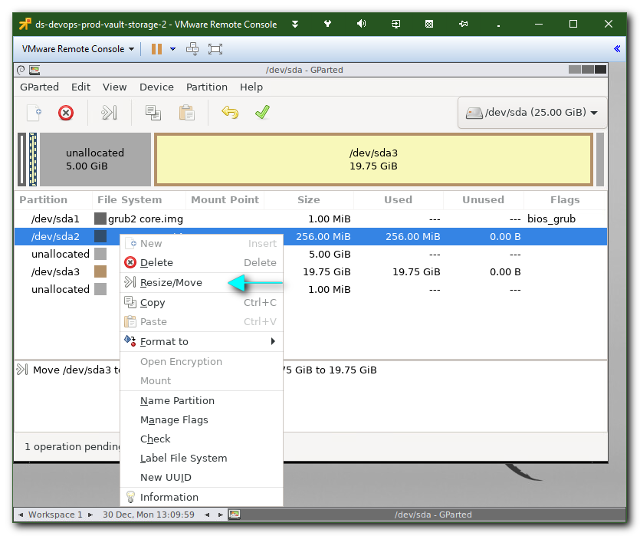

#
# It’s not work.
# To make it working - it’s need to leave “Free space following (MiB):” 5MB or similar.
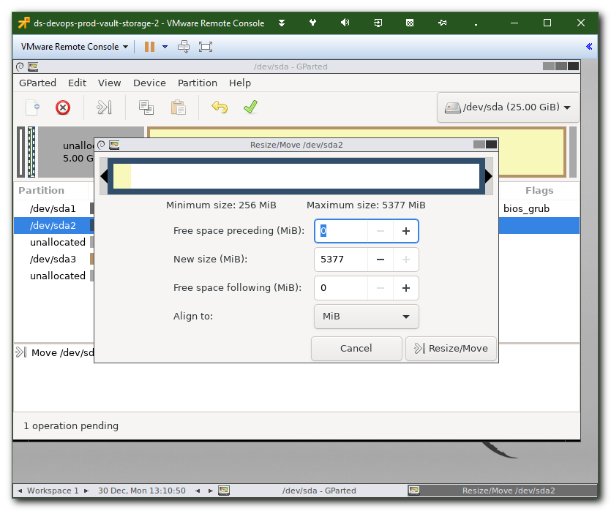
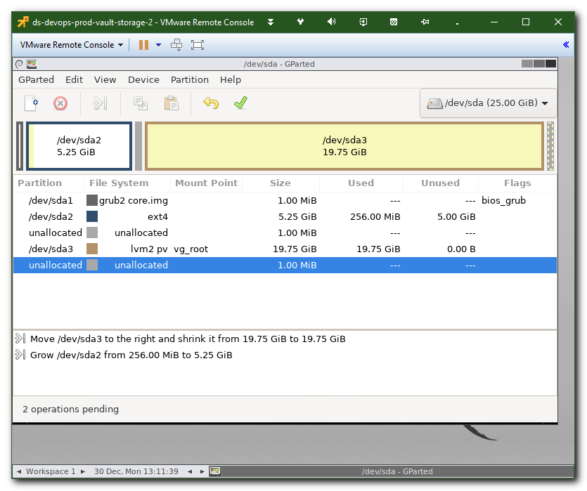

#
# Here I’ve tried “Activate” the LVM partition.
# It was not successful.
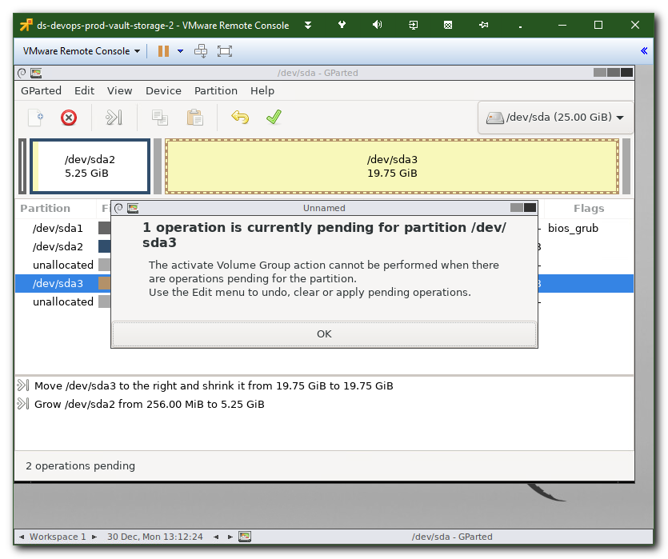
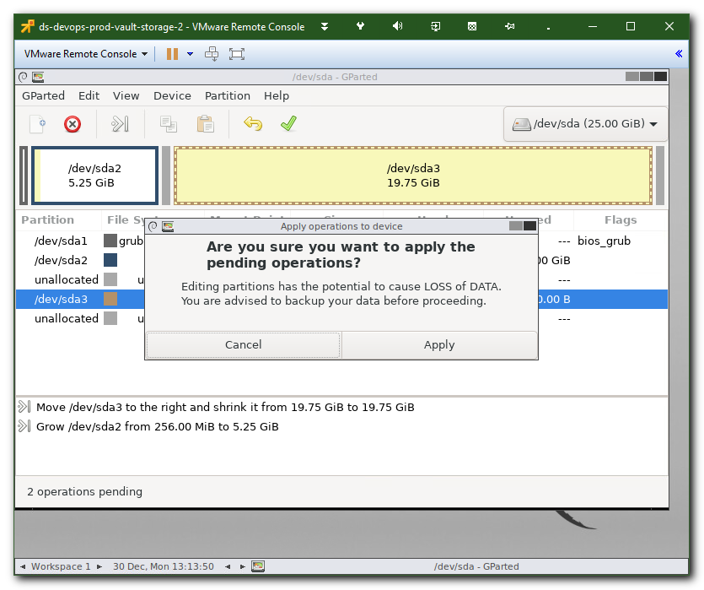
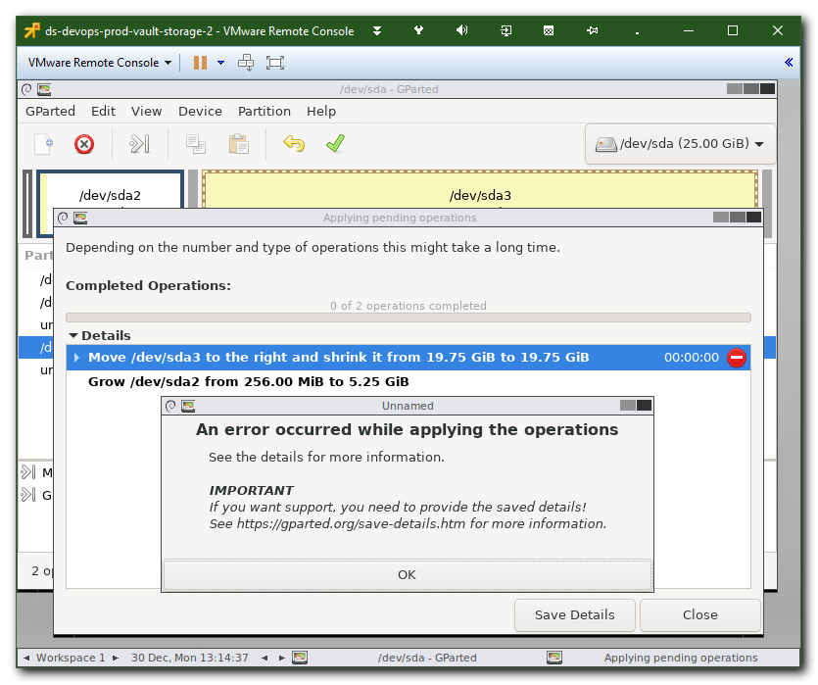
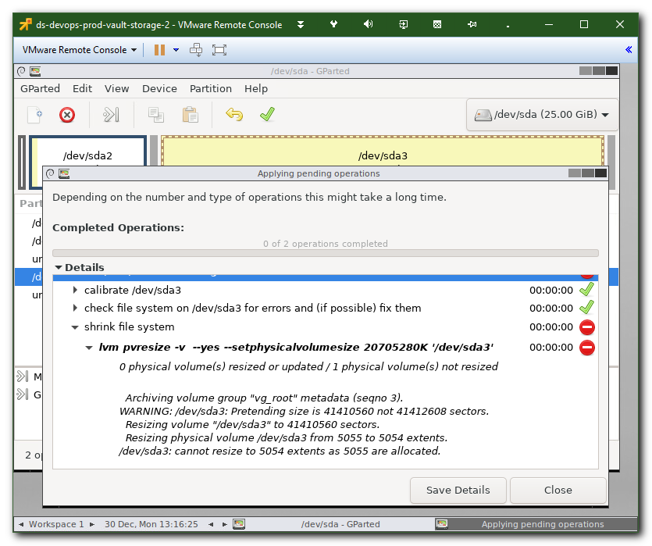

#
# It didn’t work.
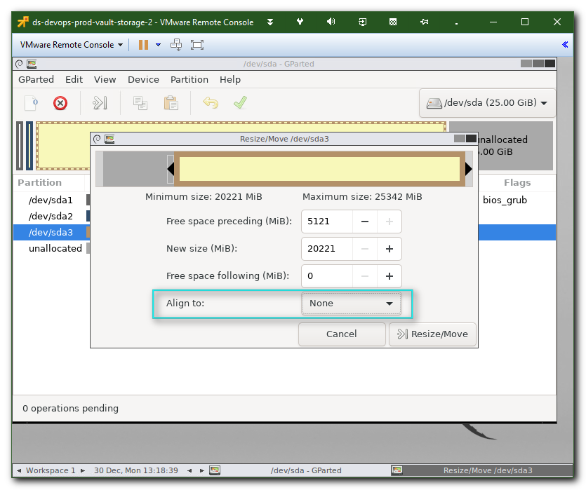
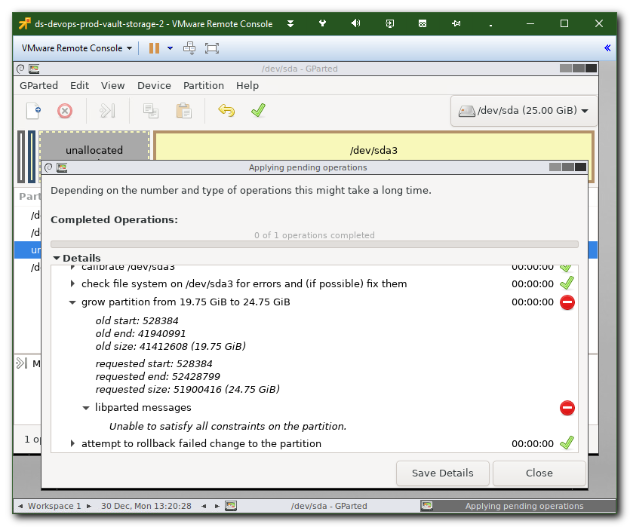

#
# I’ve leave 5MB free at the end of moved partition.
# And after that - movement starts work.

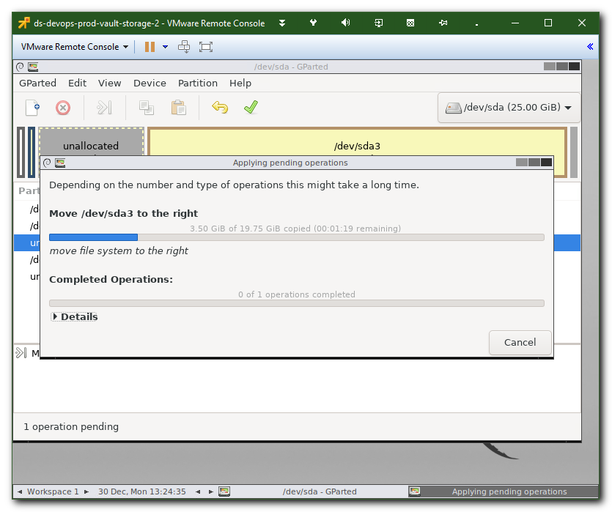

# I ignore it. And next same screen.
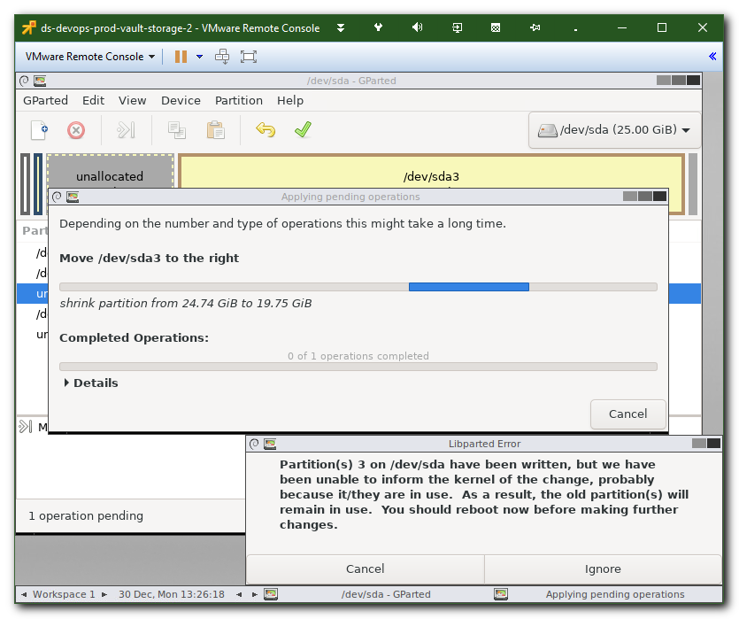
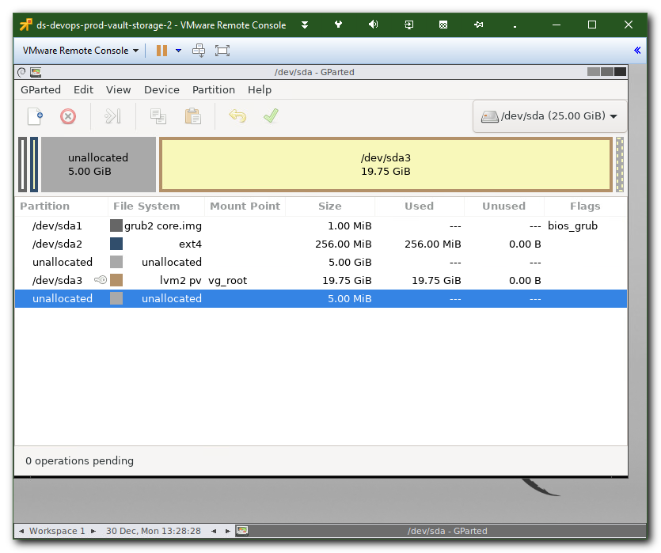

# Now I’ve started resize boot partition. And I’ve ignored warnings like below.
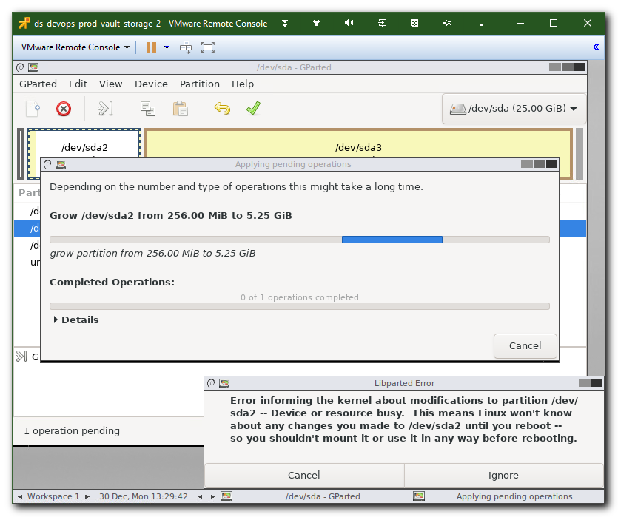
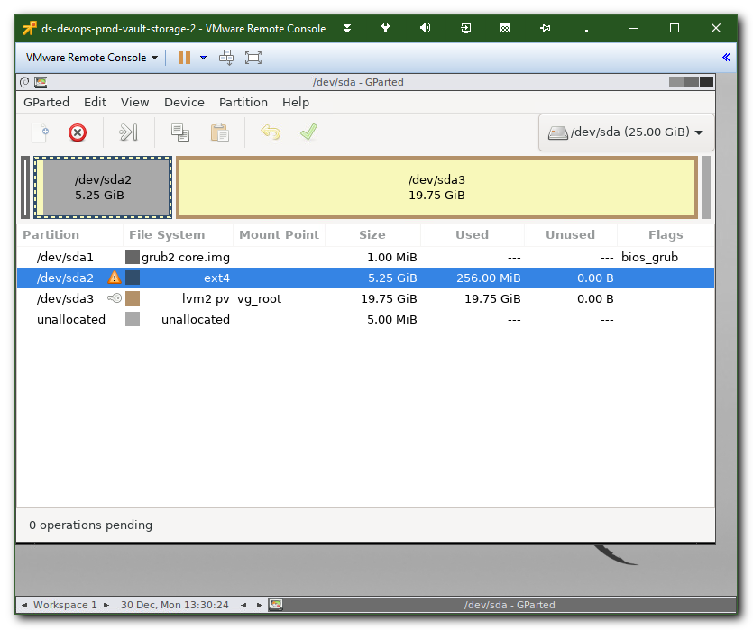
# 2MB - it’s enough.
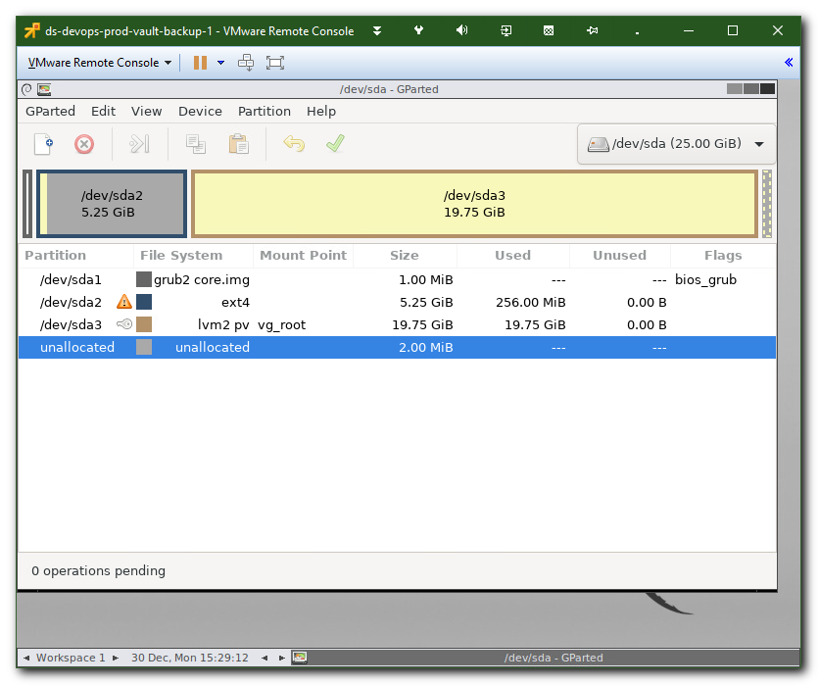

# Then - quit and exit.
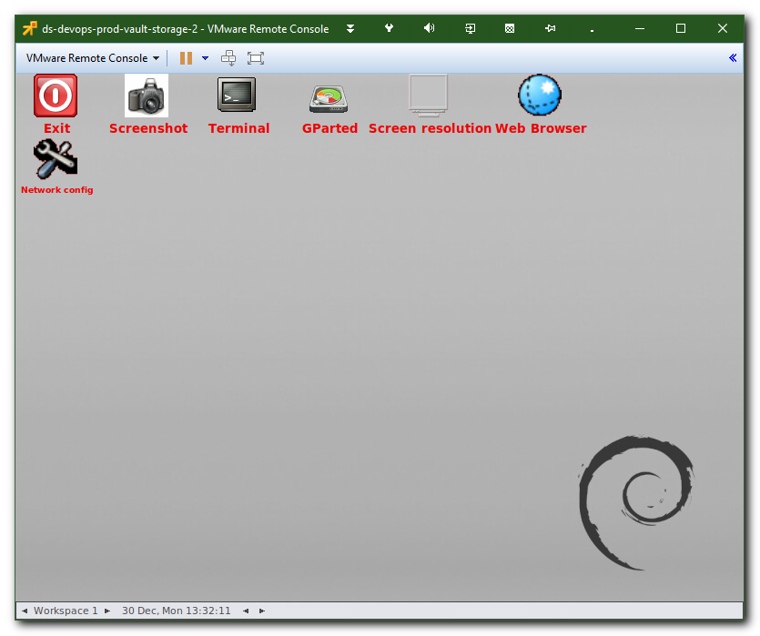

# Two fast click on Exit button.
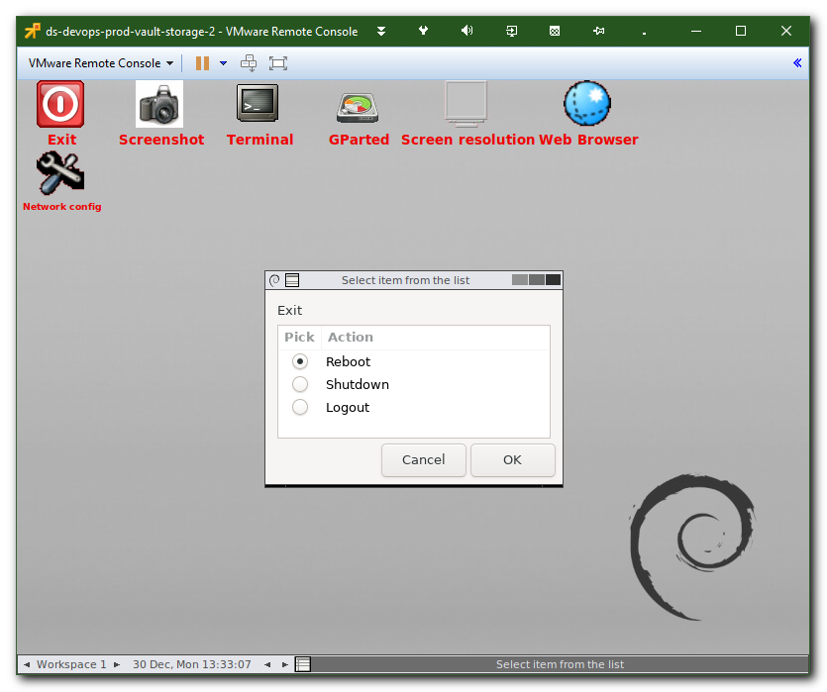

#
# After reboot.
#
root@ds-devops-prod-vault-storage-2:~# lsblk -o NAME,TYPE,MOUNTPOINT,FSTYPE,SIZE
NAME TYPE MOUNTPOINT FSTYPE SIZE
loop0 loop /snap/core/4917 squashfs 86.9M
sda disk 25G
├─sda1 part 1M
├─sda2 part /boot ext4 5.3G
└─sda3 part LVM2_member 19.8G
└─vg_root-lvol0 lvm / ext4 19.8G
sr0 rom 1024M
root@ds-devops-prod-vault-storage-2:~#

# But filesystem need to be resized. Because it still 250MB space.
root@ds-devops-prod-vault-storage-2:~# df -hT /boot
Filesystem Type Size Used Avail Use% Mounted on
/dev/sda2 ext4 240M 144M 81M 65% /boot
root@ds-devops-prod-vault-storage-2:~#

root@ds-devops-prod-vault-storage-2:~# resize2fs /dev/sda2
resize2fs 1.44.1 (24-Mar-2018)
Filesystem at /dev/sda2 is mounted on /boot; on-line resizing required
old_desc_blocks = 2, new_desc_blocks = 42
The filesystem on /dev/sda2 is now 5500928 (1k) blocks long.

root@ds-devops-prod-vault-storage-2:~#

root@ds-devops-prod-vault-storage-2:~# df -hT /boot
Filesystem Type Size Used Avail Use% Mounted on
/dev/sda2 ext4 5.1G 144M 4.8G 3% /boot
root@ds-devops-prod-vault-storage-2:~#

#
# 20201019
#
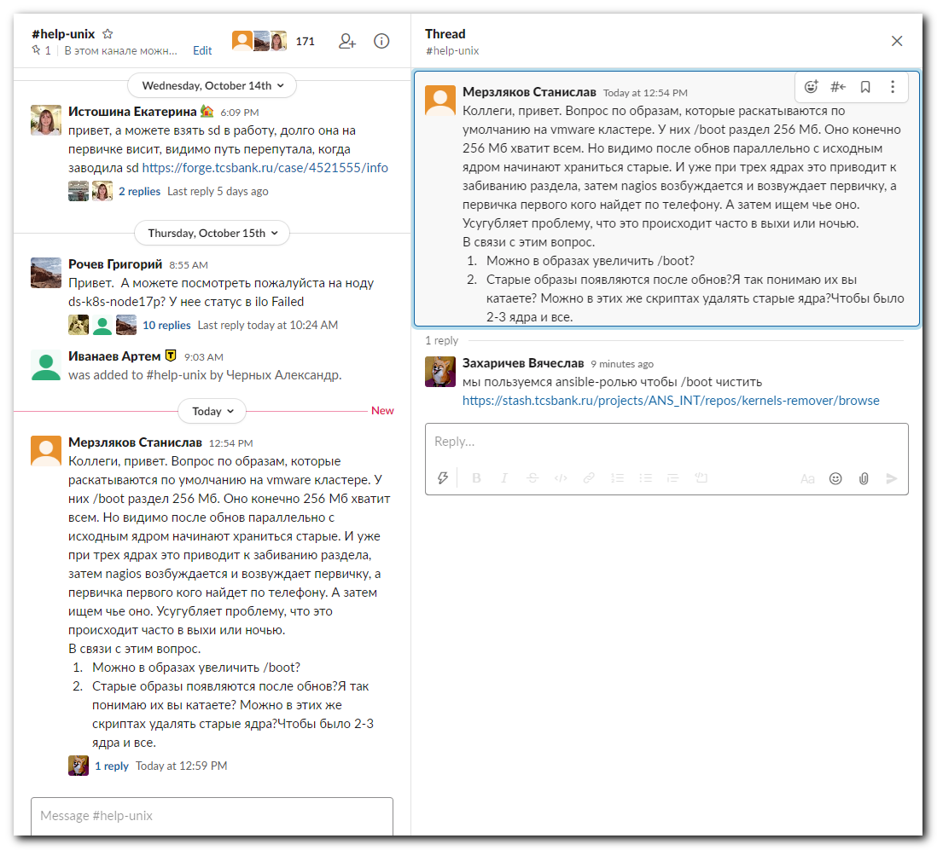

https://stash.tcsbank.ru/projects/ANS_INT/repos/kernels-remover/browse
